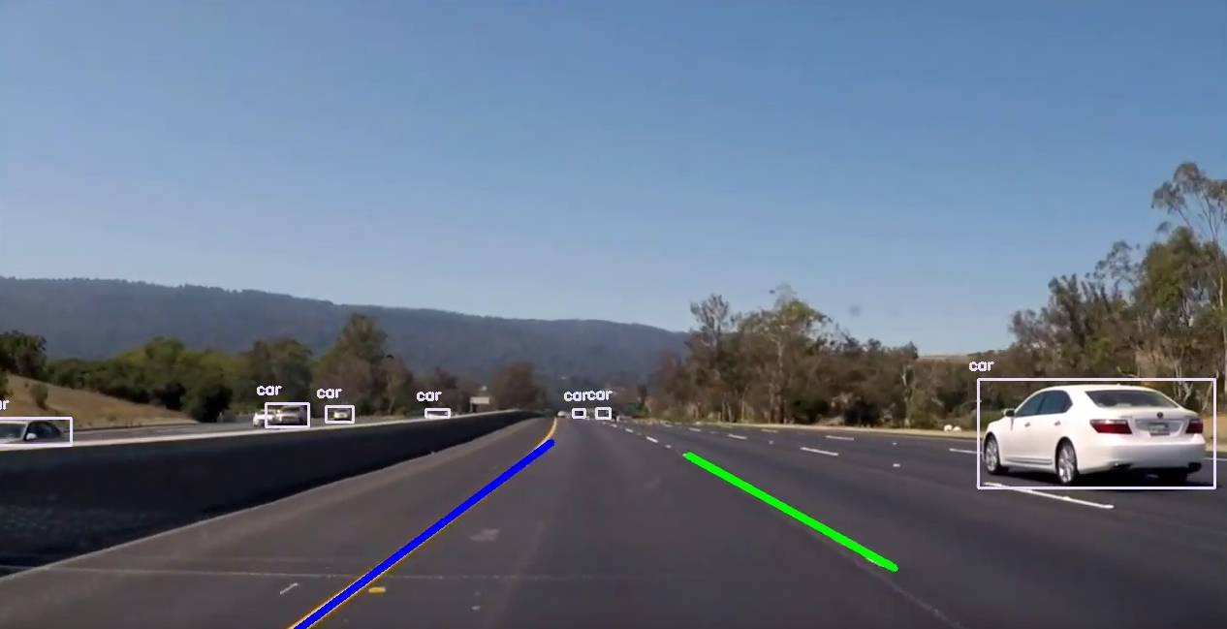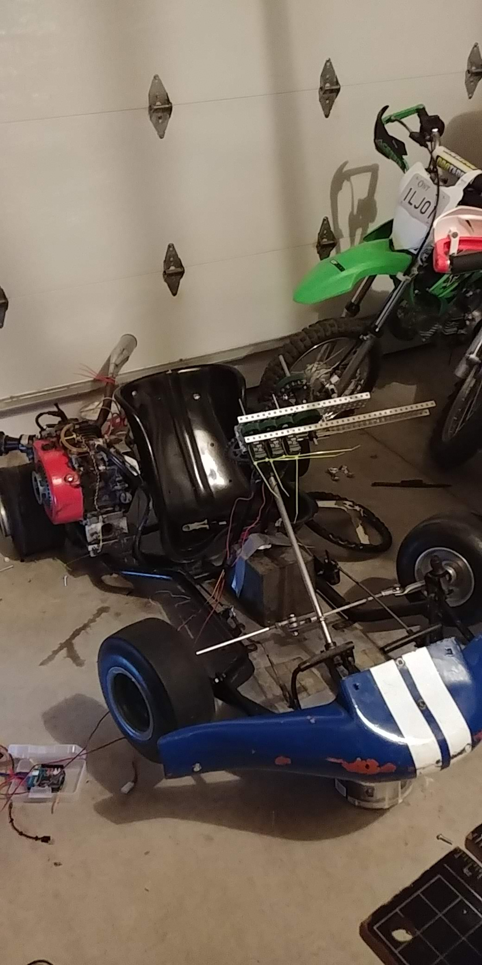

**Go Kart**

I have had numerous personal projects, but this is probably my most exciting project. In my later years of high school I have developed a certain philosophy. I am constantly coming up with crazy ideas but in the past have been nervous to act on them, with my new philosophy I simply do it. At the beginning of April I had thought I wanted to do something really big before I left high school, something to really put a lot of effort into as my duties were beginning to slow down, with the robotics season ending and pchackers hackathon on May 4th. For many people they may develop ideas by thinking of things that they know they can do, for me I simply thought, what is the coolest thing I could make. I decided the coolest thing I could make is a self driving car. Many people have told me this is an absurd task as there are multi billion dollar companies who are trying to create the exact same thing but with my new philosophy I decided to go with it. I begun by recruiting two other members, Veer Khurana and Shrey Jain to join my team. I got Veer Khurana as he has many connections to surplus stores and is good with solving things using common sense. I got Shrey Jain to join my team as he is new to programming and wanted to learn how to program on a large scale and he also is very good with logistics. I decided early on that putting a system on a real car is impractical, expensive and dangerous so I decided to buy something a little simpler and more fun. Me, Shrey and Veer pooled our money to buy a go kart, this go kart has a top speed of 75km/h. We really started construction and building in mid April and we plan to ramp up our contributions once the PCHacks 2019 hackathon is over. We currently have autonomous throttle control and have mounted a control system for the steering, I am currently working with the microcontrollers to get it controlled with an RC remote control. A week after the hackathon I expect to be running the go kart using a remote control. In my Grade 12 computer science class I actually developed the software for a self driving car using test footage before I even had the idea of developing a hardware version. Our final goal has been to complete a semi autonomous car by the end of June, Mr Knowles has asked us to present some version of the car to inspire the new SciTech students.